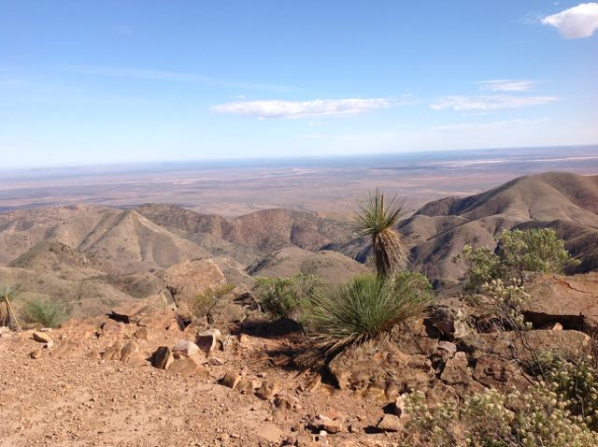
    - Out and about in VK5
  Issue 3
  January 2015

SOTA, VK5 Parks AWARD, WWFF, Portable, QRP, Pedestrian mobile

Welcome to the third edition of ‘Out and about in VK5’, a newsletter dedicated to SOTA, the VK5 Parks Award, WWFF, portable, QRP, & pedestrian mobile operation.
Well, Christmas has been & gone, and 2015 is here as well. Another year has passed us by! Last year (2014), saw lots of portable activity both here in VK5 and across Australia. The 40m band in particular was alive with both park activators and SOTA activators. There was a time, in recent years, when 40m was often very quiet over the weekend. But that is certainly not the case anymore.
There was also a time that SOTA & park activators would struggle to get the required number of QSOs to qualify a park or summit. Nowadays, activators invariably end up with a pile-up. Over the month of December 2014, there was quite a bit of park & SOTA activity here in VK5, which was pleasing to see. This was despite the often oprressive weather conditions & poor band conditions.
This newsletter is released at the start of each month and emailed as a PDF. It can also be found online at the Adelaide Hills Amateur Radio (AHARS) website at:
http://www.ahars.com.au
I welcome any news and photographs relating to the subject material.
Remember, the content, and ultimately the survival of this newsletter is entirely up to your contributions.
You can email me stories and photos to:
vk5pas@wia.org.au
73 & have fun,
Paul, VK5PAS

In This Issue

A day out in Beetaloo Valley
Ian VK5IS has been bitten by the SOTA bug Page 4
Some Christmas activations
Park & summit activations over Christmas by Paul VK5PAS Pages 4 & 5

A day out at Myponga
A group of mates, portable at beautiful Myponga Pages 6 & 7

New SOTA Challenge
Info on the new 2015/16 SOTA Challenge Page 7

A VK5 on the loose in NSW & Victoria
John VK5BJE has been active interstate, activating parks & summits Page 7

Recent SOTA Activations
Details of recent VK5 SOTA activations Page 8

A scary snake
Peter VK5NAQ’s thoughts on the Death Adder Page 8

Snake bite
Some general info on snakes in S.A. and what to do if bitten. Pages 8 & 9
Recent VK5 Park Activations
A list of recent park activations in S.A. Page 9
KRMNPA Merit Award
The KRMNPA merit award was recently issued to VK5PAS. Page 10
Update on VK5 Parks Award
An update on the VK5 Parks Award. Page 10
VK5 Parks anniversary
Info on the upcoming 2nd year anniversary weekend in March 2015. Page 11
Do it all again in 2015
Its now a new calendar year, so there’s SOTA & parks points up for grabs. Page 11
Southern Flinders get together
Some info on the recent get together by the keen Mid North group Page 12
On line park payments
You now need to pay on line for National Park entry to some parks Page 12

New name for park
Coongie Lakes NP now has a new name Page 12
Interesting thread
A current interesting thread on the SOTA Yahoo group re spots/alerts Page 13
Mount Brown CP activation
Info on Les VK5KLV & Peter VK5KPR’s activation of Mt Brown CP Page 13
VK5RG in the UK
A photo from a trip to the UK by Rob a number of years ago Page 14
The 2014/15 UTC rollover
The 2014/15 UTC rollover saw a huge amount of SOTA activity Pages 14 , 15, & 16
Recent award recipients
A list of recent award recipients from VK5 Page 16
Doc’s portable set up
Doc VK5BUG’s pedestrian mobile set up Page 16

A day out in Beetaloo Valley
By Ian VK5IS
On Tuesday 30th December 2014, Ian VK5IS headed out to do a bit of portable work. Ian worked a number of SOTA stations………
I have been participating as a SOTA chaser without officially logging my contacts for several months. Nev, VK5WG who is a keen chaser, has talked me into submitting my first log for my chasing efforts on 30-12-2014. Thanks Nev!
During the day Nev & I liaised on 2 meters while chasing mainly on 40 and 20 meters. All of my contacts were on 40 meters which has been a fickle band of late at my qth.
I normally use my MST400 kit transceiver which runs around 5 watts on 40 meters to do the chasing. It always astounds me how well we can do with the low power. Because band conditions were so bad I had to cheat by using my IC7200 to make the first three contacts with VK3MCD, VK3KAB and VK3ANL on the day.
About lunch time I decided to pick up my portable station consisting of a 9 meter squid pole, linked dipole 40-20-10 and FT817 with internal battery, and take the walk up a small hill on my block at Beetaloo Valley.
After setting up for 40m I worked Les VK5KLV and Peter VK5KPR who were activating Mount Brown National Park near Quorn. I was then called by John VK5BJE who was at Livingstone National Park in VK2. The 817 to 817 contact with John was 100%.
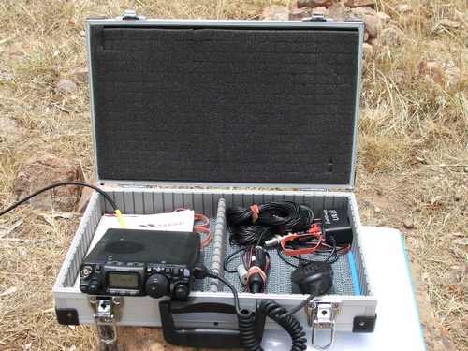
Ian’s kit.
image courtesy of Ian VK5IS
I managed to make contact with Andrew VK1NAM who was on VK2/SM-065 Box Ridge. I listened on 6 meters and heard VK4RTL and VK4RSC beacons both s9 so I called cq for a while but no joy. After about an hour and a half I decided to up stumps and get back to my home station and higher power where I managed to log 4 more sota stations making a total of 8 for the day.
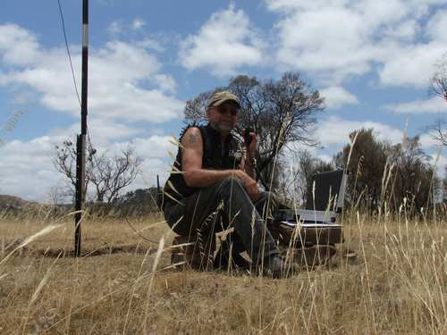
Ian operating portable.
image courtesy of Ian VK5IS.

Some Christmas activations
By Paul VK5PAS
Early on Christmas day, my wife Marija and I headed up to Whyalla to spend time with Marija’s family for Christmas. We had a great time and I returned to Mt Barker, a number of kg heavier due to my mother in law’s cooking!
Whilst up there I did manage to activate a few parks & a summit (a few new ones for me).
Our first activation was the Munyaroo Conservation Park on the afternoon of Friday 26th. Access to this park is across two different agricultural / pastoral properties off the Lincoln Hwy, and 4WD is recommended. A total of 29 QSO’s in the log from the park.
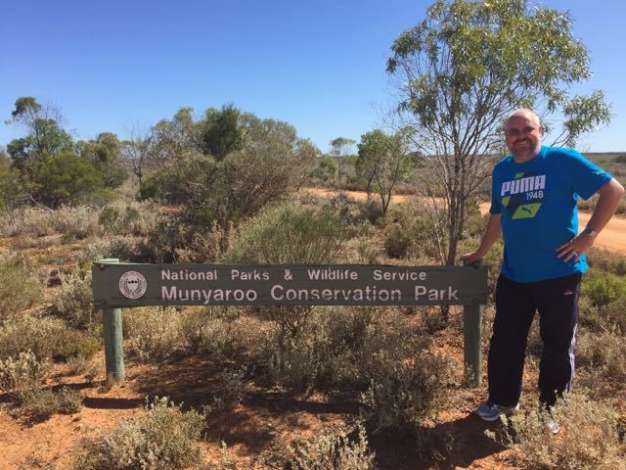
Paul VK5PAS in Munyaroo CP.
On Saturday 27th we activated the Whyalla Conservation Park, and we were joined by Mark VK5QI who had also been visiting family in Whyalla for Christmas.
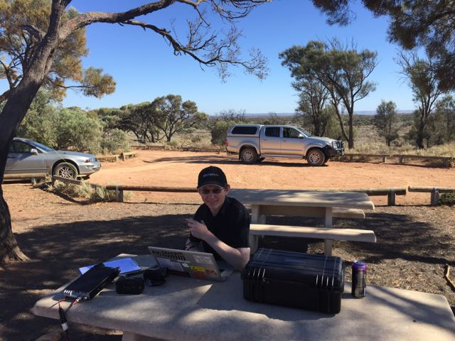
Mark VK5QI in the Whyalla CP.
We set up at Wild Dog Hill, which is a spectacular part of the park. Sadly the summit does not qualify for SOTA (it does not have sufficient prominence). Band conditions on 40m were challenging, with lots of QSB. However, Mark and I managed about 20 contacts each, including a contact with Ben VK5TX who was on the top of SOTA peak, Mt Gawler, VK5/ SE-013.
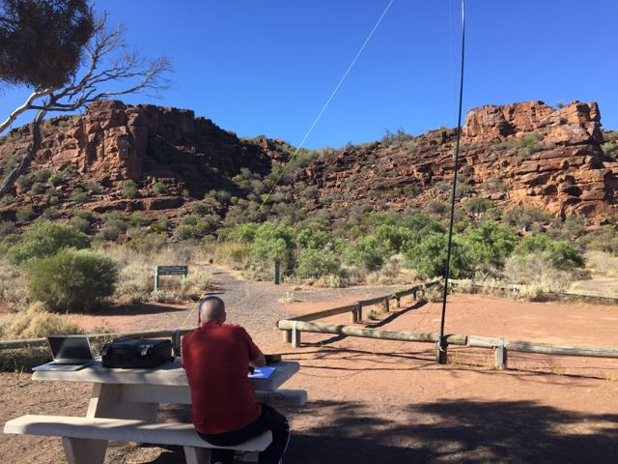
Paul VK5PAS in the Whyalla CP, with Wild Dog Hill in the Background.
And then in the afternoon, Marija and I climbed SOTA summit, The Battery VK5/ NE-055 ,which is located within the Mount Remarkable National Park, VKFF-360. This was a 11-12 km walk on a warm day and it did take it out of us. However we were rewarded with spectacular views of Spencer Gulf and the National Park.
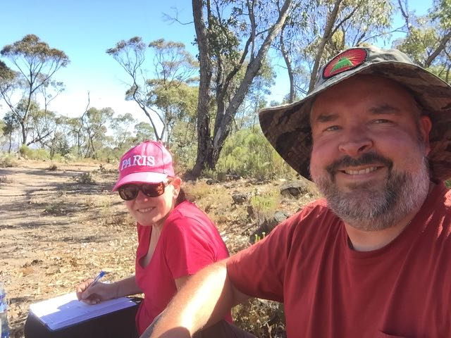
Paul & Marija at The Battery.
After an hour on the summit we had a total of 39 contacts in the log from VK2, 3, 4, 5 & 7, who were keen to get this activation in their log (qualified for SOTA, VK5 Parks, & WWFF).
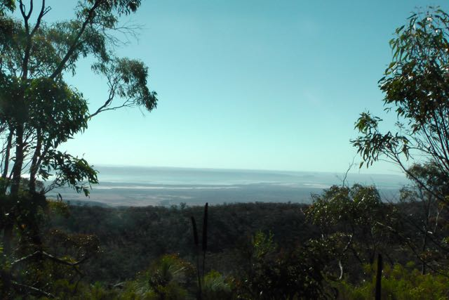
View of Spencer Gulf.
On Sunday morning, 28th Dec, we had intended to climb Mount Remarkable summit, but this was another 12-13 km walk, and it was hot! Hotter than the day before. So we opted out, and headed south to activate Bumbunga Hill, VK5/ SE-015, near Lochiel. Although this is just a 1 pointer, the summit offers spectacular views. Bumbunga Hill is 413 m ASL, and access is across private property.
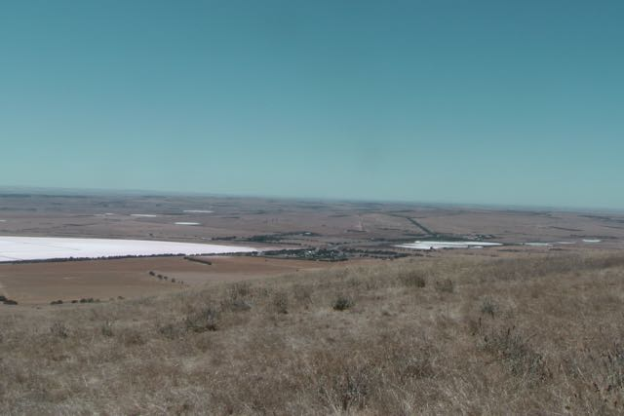
View towards Lochiel & Bumbunga Lake.
About an hour was spent on the summit, with a total of 53 contacts in the log into VK1, 2, 3, & 5. This included a contact with Tom VK5FTRG who was portable in the Canunda National Park in SE South Australia.
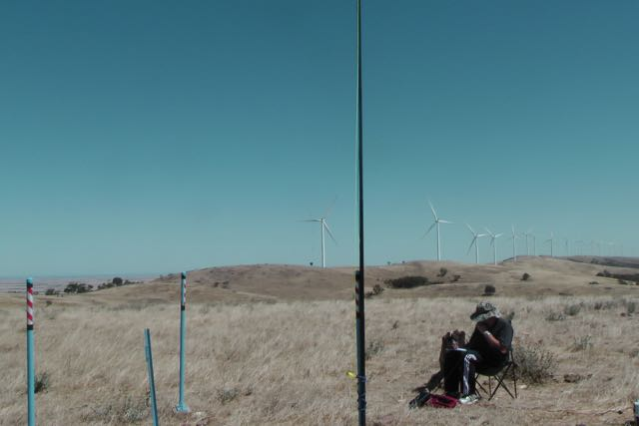
Paul VK5PAS at Bumbunga Hill.
Thanks to everyone that called. More info, photos, video on my Wordpress site at…..
https://vk5pas.wordpress.com/

A day out at Myponga
By Theo VK5MTM

On the afternoon of Sunday December 28th, Theo VK5MTM, Dave VK5MRD, Andy VK5AKH and Kevin VK5KU set up a portable HF station on the hills of Myponga, approximately 60 km south of Adelaide. The aim of this activity was for a few fellow hams to get together and get away from all the hustle and bustle of the city and its associated QRM for some Christmas holiday ham radio fun. The spot is totally noise free and also has a fantastic view of Adelaide’s southern suburbs.
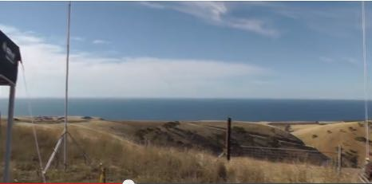
The operating spot.
Image courtesy of VK5MTM
The station comprised of a Yaesu FT-840 and an Icom IC-7100 HF transceiver powered by a large 100AH SLA battery. Antennas used were a Station Master vertical, a multi-band folding hex beam with “Armstrong” rotator and a squid pole antenna. A portable gas barbeque also aided with the feeding of hungry hams!
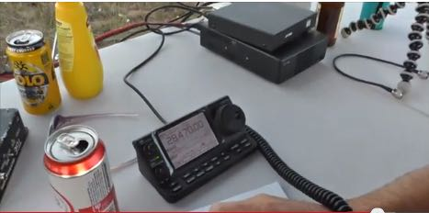
Image courtesy of VK5MTM
WX was a pleasant 29 degrees with a light breeze from the west. The station was fully setup and we made our first contact at 3.32pm local time.
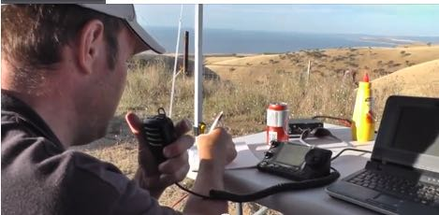
Dave VK5MRD.
Image courtesy of VK5MTM
Operation started on the 10 meter band, our first QSO being with Stuie, VK8NSB. Several contacts to Japan were also made with the Station Master antenna at first as the hex beam wasn’t looking happy on the antenna analyser when first put up in the air. After further tests and raising and lowering a few more times it was determined that a faulty piece of coax was the culprit.
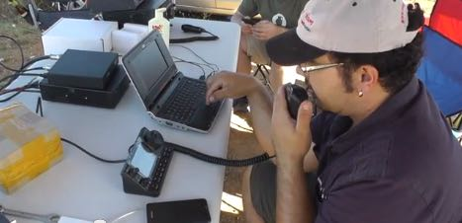
Theo VK5MTM.
Image courtesy of VK5MTM
DX from New Zealand and Asia to as far as Europe was worked. Each operator operated using their own callsign within their respective license and band restrictions. Contacts were made on the 10, 12, and 40 meter bands with the majority of QSOs being on 10 meters.
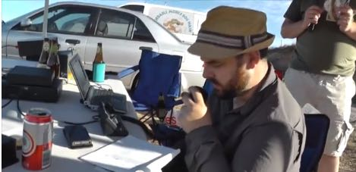
Andy VK5AKH.
Image courtesy of VK5MTM
We were spotted on the DX cluster several times leaving Dave, VK5MRD on the receiving end of a nice pileup of Europeans on 10m. All up around 70 voice QSOs were completed. Countries worked were: Australia, New Zealand, China, Thailand, Taiwan, Malaysia, Japan, Ukraine, Greece, Russia, Italy, Poland, Belarus, Romania, Denmark, Austria, Sweden, Finland and France.
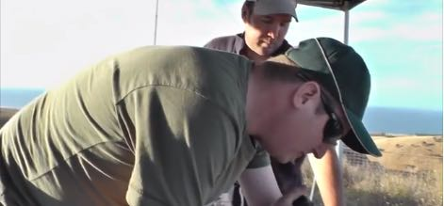
Kevin VK5KU.
Image courtesy of VK5MTM
We started the pull the station down at last light and then drove home, chatting amongst ourselves and others on the local VK5RSB 70cm repeater of the fun that was had.

A video of the setup and of several contacts made can be seen here:

https://www.youtube.com/watch?v=hgtpPHJ4k8g

73, good DX and HNY de VK5MTM.

New SOTA Challenge for 2015/2016
By Paul VK5PAS

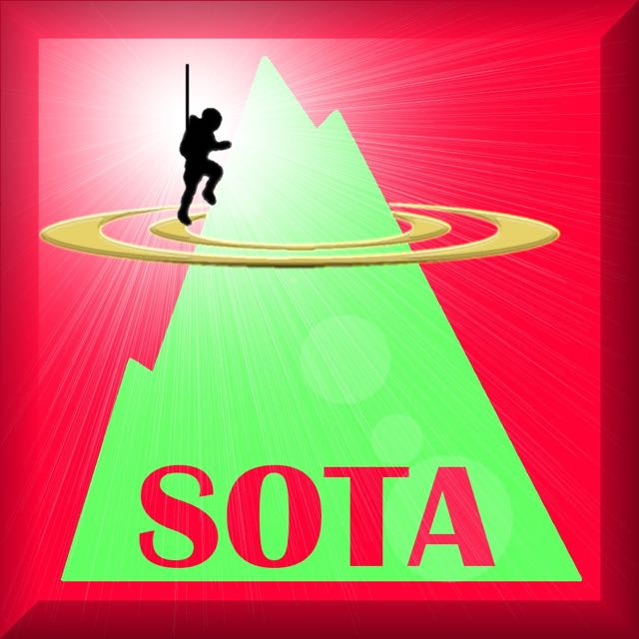

The latest Summits on the Air (SOTA) Challenge has been announced. The previous challenge period 2013/2014 was the 12m band.

In 2015/2016, the official SOTA challenge will be to make contacts on 6m and 10m.

Chasers: for every unique summit you chase on 10m or 6m you get a multiplier. For every unique activator chased you get 1 chaser challenge point. Your final score is chaser challenge points* multipliers.

Activators: for every unique summit you activate on 10m or 6m you get a multiplier. For every unique chaser workedyou get 1 activator challenge point. Your final score is activator challenge points * multipliers.

The challenge runs for 6 months in total, split into 2 separate 3 month periods. Each period coincides with the Sporadeic E season in either the Northern or Southern Hemispheres.

The first period runs from 15th May 2015 to 14th August 2015. The second period runs from 15th November 2015 to 14th February 2016.

No matter where you live, you can operate in both periods, but during 1 period your chances of making contacts are massively improved.

There will be certificates for the top chaser and activator. There will be certificates for best chaser and activator on an association by association basis ass well.
The final number of certificates awarded will be based on the activity levels.

A VK5 on the loose in NSW & Victoria
By Paul VK5PAS

John VK5BJe has been active in NSW & Victoria, activating parks and summits. Here is a list of SOME of his activations…..

- Little Desert NP, VKFF-291
- Mt Moliagul, VK3/ VN-024
- Greater Bendigo NP, VKFF-623
- Scheyville NP, VKFF-444
- Cattai NP, VKFF-292
- Livingstone NP, VKFF-292
- Brisbane Ranges NP, VKFF-055

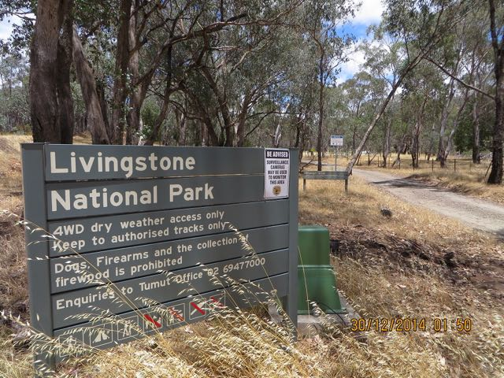
Livingstone NP.
Image courtesy of VK5BJE
Looking forward to hearing more about your trip when you get home John.

More information on John’s activities can be found at his WordPress site at…..

http://vk5bje.com/

RECENT VK5 SOTA ACTIVATIONS / ACTIVATORS

Again, not many VK5 SOTA activations for this period. It has been mentioned before, but the tyranny of distance is a problem here in VK5. And the weather is certainly hotting up. So I think those 2 aspects are certainly contributing to the number of VK5 SOTA activations here.
- VK5/ SE-001 Mt Bryan, Paul VK5PAS (3/12/2014 & 1/1/2015)
- VK5/ NE-055 Mt Ndgadjuri, Ian VK5CZ (31/12/2014 & 1/1/2015)
- VK5/ SE-013 Mt Gawler, Bob VK5FO (31/12/2014 & 1/1/2015)
- VK5/ SE-015 Bumbunga Hill, Paul VK5PAS (28/12/2014)
- VK5/ NE-055 The Battery, Paul VK5PAS (27/12/2014)
- VK5/ SE-013 Mount Gawler, Ben VK5TX (26/12/2014)
- VK5/ SE-013 Mount Gawler, Bob VK5FO (9/12/2014)
- VK5/ SE-013 Mount Gawler, Bob VK5FO (6/12/2014)

A scary snake
By Peter VK5NAQ
A few weeks ago I spoke to Paul VK5PAS in the Munyaroo Conservation Park on the Eyre Peninsula. Paul was deep in the territory of the Death Adder.
I am generally not scared of snakes but this one frightens the s… out of me!
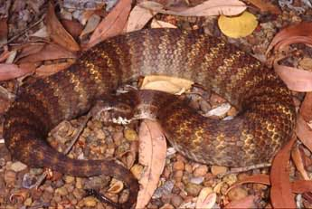
The Death Adder.
Image courtesy of www.pilbarapythons.com
I don’t usually ask my subordinates to do things I won’t, but this snake was one instance that was an exception to the rule!

As a loco driver foreman I would not get off the loco from Coonamia to Whyalla when I worked from Port Augusta.
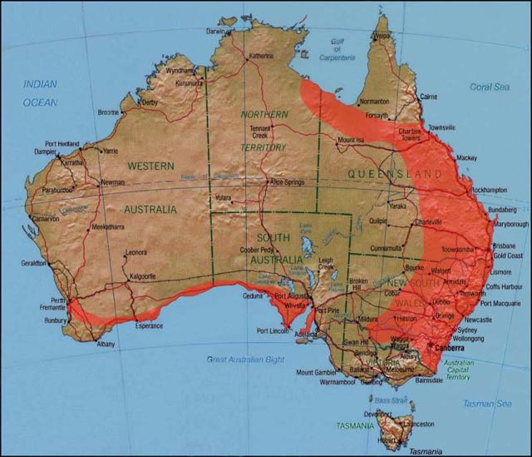
Distribution map of the Death Adder
Image courtesy of www.pilbarapythons.com

Snake bite
By Paul VK5PAS
Following on from Peter’s story of the Death Adder, I thought I would touch a little bit on the issue of snakes. Fortunately during all of my park & SOTA activations, I have only seen a few snakes.
Brown snakes are common across all areas of the State, but there are also Tiger Snakes around the River Murray and the South East, and the Red-Bellied Black snake in the Mt Lofty Ranges. Death Adders (as mentioned by Peter) live in coastal areas of the Eyre and Yorke Peninsulas, and Copperheads are common on Kangaroo Island. While Mulga snakes are regulars in mining areas and regions north of Port Augusta.
All of these species are venomous to various degrees and should be avoided.
Most snake bites happen when people are trying to catch or kill a snake. So, the best course of action is simply to take no action at all. Stand back and wait for the snake to move on.
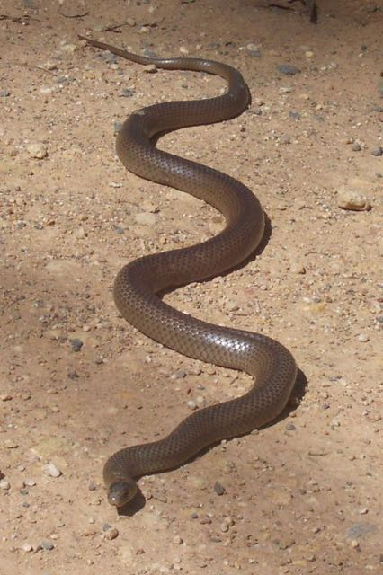
Image courtesy of www.wikipedia.com
If you should get bitten…..
- Stay as still as possible.
- A broad bandage should be applied to the bite area with about as much pressure as would be used for an ankle sprain. Its purpose is to compress the local lymphatic channels and not to cut off blood supply like a tourniquet.
- The bandage should then be extended over the rest of the bitten area and limb if possible, including the top of the clothing. Do not remove clothing as it means limbs are being moved.
- The bitten limb should be immobilised with a splint, a crucial element of the treatment.
- After first aid, medical treatment whould be brought to the patient. If the patient gets up and walks, a lot of the first aid is negated.

Medical information courtesy of www.abc.net.au

RECENT VK5 PARK ACTIVATIONS

- Kaiserstuhl Conservation Park, Will VK5AHV (31/12/2014)
- Mount Brown Conservation Park, Les VK5KLV & Peter VK5KPR (30/12/2014)
- Ian VK6PXF/5, The Coorong National Park (29/12/2014)
- Mount Remarkable National Park, Paul VK5PAS (28/12/2014)
- Whyalla Conservation Park, Paul VK5PAS (27/12/2014)
- Whyalla Conservation Park, Mark VK5QI (27/12/2014)
- Munyaroo Conservation Park, Paul VK5PAS (26/12/2014)
- Morgan Conservation Park, Bob VK5FO (26/12/2014)
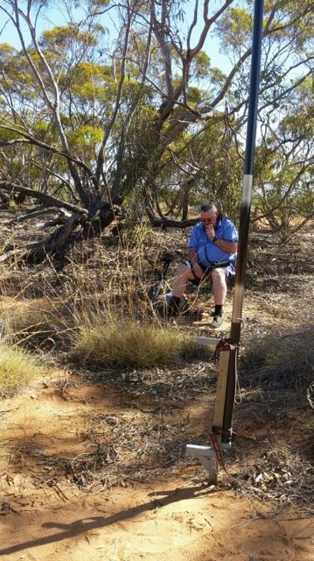
Bob VK5FO in Morgan CP.
Image courtesy of Bob VK5FO

- Mount Magnificent Conservation Park, Paul VK5PAS (21/12/2014)
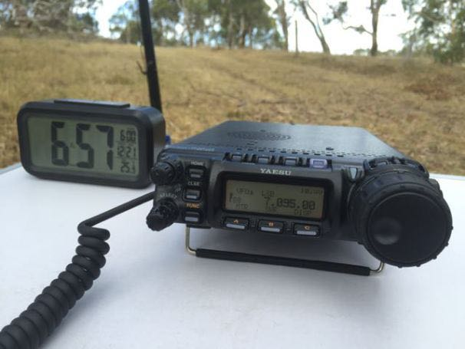
Yaesu FT-857d in action at Mt Magnificent CP.
- Messent Conservation Park, Gordon VK5GY (21/12/2014)
- Sandy Creek Conservation Park, Stuart VK5STU (21/12/2014)
- Belair National Park, Paul VK5PAS (20/12/2014)
- Swan Reach CP, David VK5NQP (20/12/2014)
- Ridley CP, Paul VK5PAS (6/12/2014)
- Swan Reach CP, Paul VK5PAS (6/12/2014)
- Monarto CP, Paul VK5PAS (2/12/2014
- Marne Valley CP, David VK5NQP (20/12/2014)
- Nullabor National Park, Ian VK6PXF/5
- Gawler Ranges NP, Ian VK6PXF/5.
- Onkaparinga River NP, Paul VK5PAS (15/12/2014)
- Ridley CP, Paul VK5PAS (6/12/2014)
- Swan Reach CP, Paul VK5PAS (6/12/2014)

KRMNPA Merit Award
By Paul VK5PAS
In mid December, I received the Merit Award for the Keith Roget Memorial National Parks Award (KRMNPA). This was for having made contact with ALL 45 National Parks in Victoria.
The aim of the KRMNPA is to encourage portable operation in Victoria’s 45 National Parks.
I have activated just 7 Victorian National Parks.
However, John VK5BJE is well on his way to having activated ALL 45 Victorian National Parks.
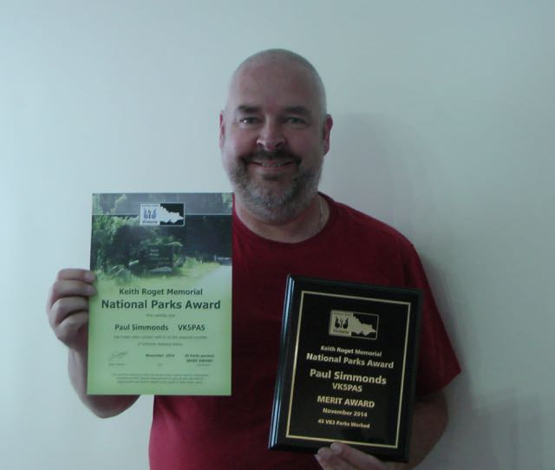
For more information on the KRMNPA please have a look at…...
https://www.amateurradio.com.au/awards
Thanks to Tony VK3VTH, who is the KRMNPA Awards Manager.

Update on VK5 Parks Award
By Paul VK5PAS
Just a reminder that the certificates for the VK5 Parks Award are now offered for FREE. Yes, that’s right, for FREE.
I can still print them out and send them at a cost of $5.00 per certificate (which includes postage, glossy photo paper, ink costs, etc).
However, they are now available via email in PDF format.
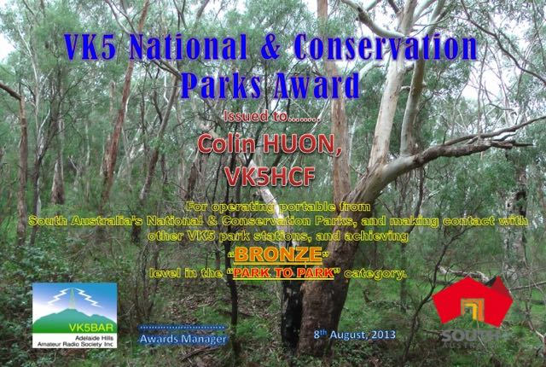
Please use the Excel spreadsheet when applying for the award. The spreadsheet can be found in the Files section on the VK5 Parks Yahoo page (which is FREE & EASY to join).
https://au.groups.yahoo.com/neo/groups/sanpcpa/info
New rules uploaded to the VK5 Parks Yahoo group.
Two new parks have also been added…
- Paranki Lagoon CP
- Mantung CP

More info on the DEWNR website.
I am also in the throws of designing a VK5 Parks award logo, and I am trying to overcome some patent issues. I will keep you posted.
And additionally, work is continuing on a database.

2nd year VK5 Parks anniversary
By Paul VK5PAS
A reminder that the 2nd year VK5 Parks anniversary activation weekend is to be held on…
Saturday 28th & Sunday 29th March 2015.

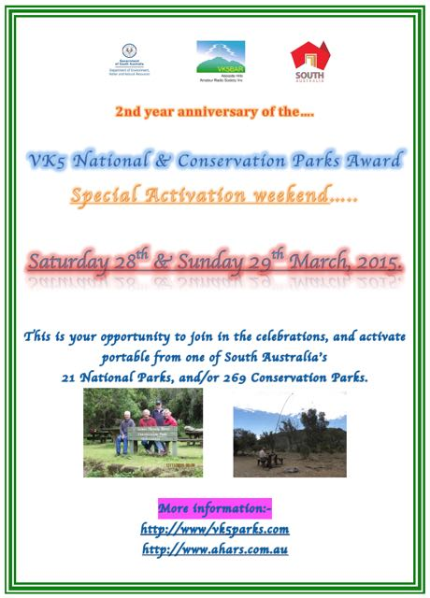
If you are going to activate a park, PLEASE send me the details so that I can attach your intentions to the master spreadsheet. This will prevent double up activations, and will act as a one stop shop for the park Hunters.
So far I have heard from the following amateurs who intend to activate VK5 Parks…..
- Tony VK3VTH
- Chris VK4FR
- David VK5NQP

Last year there were about 29 activators, who activated 98 VK5 National & Conservation Parks. Lets see if we can make the 2015 event even bigger.
Looking forward to hearing from you.

Do it all again in 2014
By Paul VK5PAS

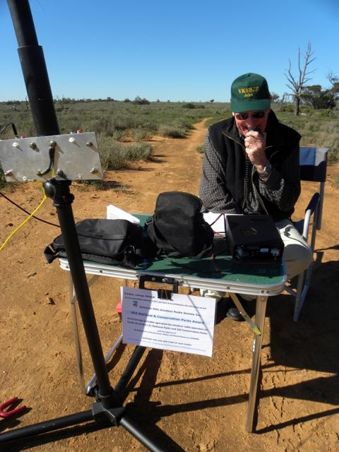

Just a reminder that as of 1st January 2015, you will be able to claim points for reactivating summits you ascended in the last calendar year. Time to get your boots on again!

And the same applies with the VK5 National & Conservation Parks Award for activators. Plenty of point up for grabs!

Southern Flinders get together
By Roger VK5NWE

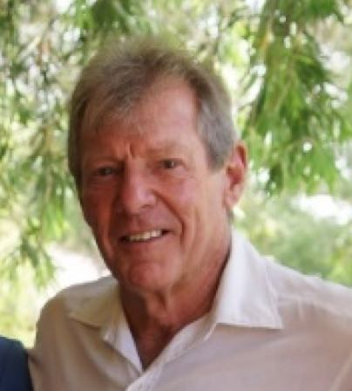
During one of our regular 2m morning chats on 146.600, it was suggested that it was about time we all met for lunch somewhere and engage in some social discourse. John, (FMJC), was nominated for the job of organising the venue and it was agreed that we should all meet at Bowmans Park just north of Crystal Brook for lunch on Saturday the 29th of November at 11.30am.
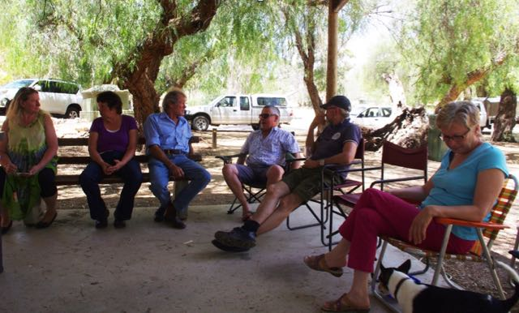
And so it was that an equal temper of heroic hearts, with their partners, braved the warm weather and assembled under the shelter provided at the park. There was a cool breeze blowing so we were all quite comfortable.
Those present were, Ian (CZ) and Halima, Neville (WG) and Norma, John (FMJC) and Sandy, Ian (IS) and Julie, Dave (DMC) and Debbie and Roger (NWE) and Robyn. Unfortunately Bill (MBD) and Haley were unable to be present due to illness.
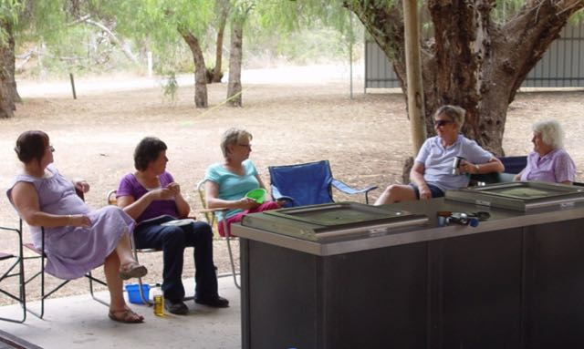
We all enjoyed a very nice lunch, cooked on the park electric barbeques, and salads and sweets were also supplied by the girls. (Julies Pavlova was so good I had 3 servings).
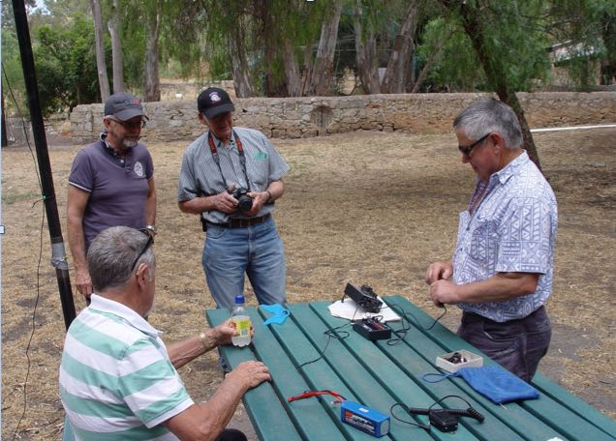
Ian demonstrating his cw station to John, Ian & Neville.
Image courtesy of Roger VK5NWE
The inevitable segregation came to pass just after lunch when Ian (CZ) set up his portable SOTA station on a nearby park bench and with a linked dipole on top of his squid pole began working some CW stations on the 40m and 20m bands. His simple light station was impressive and some new ideas were noted for future portable work.
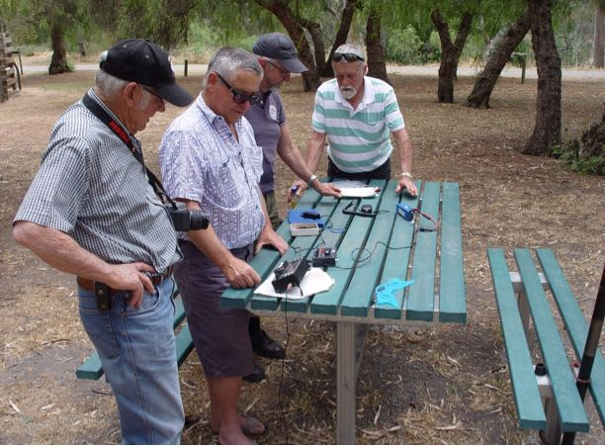
It has been a long time since the last gathering of amateurs at Bowmans Park and the upgraded facilities were certainly appreciated by us all. A walk around the old station buildings was worthwhile as a lot of history is still in evidence and it came to be known to us that Ian and Julie were married here on the 13th of April 1991. The group reluctantly disbanded at around 4.30pm with a promise to “do it again sometime”
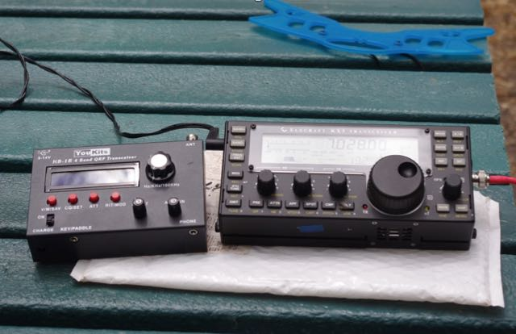
Some of Ian VK5CZ’s QRP equip used for SOTA activities.
Image courtesy of Roger VK5NWE

Online park payments
By Paul VK5PAS
Just a reminder that online payment now applies for a number of South Australian National Parks including Mount Remarkable National Park & Innes National Park.

Marija and I recently paid on line for Mt Remarkable. Surprisingly you don’t need to display a receipt. You just need to produce one if challenged.

As we entered the park there was a couple there from interstate who were rather disappointed that they could not place money in the locked container, and had to pay on-line. They left, without entering the park.

Not sure this is a great idea by DEWNR. Another cost cutting exercise I suspect?

New name for park
By Paul VK5PAS
The Coongie Lakes National Park is now known as the Malkumba-Coongie Lakes National Park. This park, which is 100 km north of Innamincka along the Strezelecki Track, is one of the most spectacular of South Australia’s natural attractions.

Interesting thread on SOTA Yahoo
By Paul VK5PAS
There is currently an interesting thread on the SOTA Australia Yahoo group, relating to ‘Chasing styles’ and the use of phone apps such as SOTA Goat and Rucksack radio.
Some are suggesting that there is overuse of spotting and alerting facilities.
To read the posts, go to the SOTA Australia Yahoo group at…..
https://au.groups.yahoo.com/neo/groups/SOTA_Australia/info
My own personal opinion? SOTA is fortunate to have such phone apps, which draw in the SOTA Chasers. The park activities, including the VK5 Parks award and WWFF do not. And this certainly affects the number of QSOs that park activators get in the log.

Mount Brown CP
By Les VK5KLV
On 30th December, 2014, Peter (VK5KPR) and I (Les, VK5KLV) left our homes at 7.00 am local time, met along the road and travelled in convoy to Quorn where we had a brief stop and then proceeded to the Mount Brown Conservation park via the Richman Valley road. Richman Valley was named after an early grazier who moved his sheep through the area.
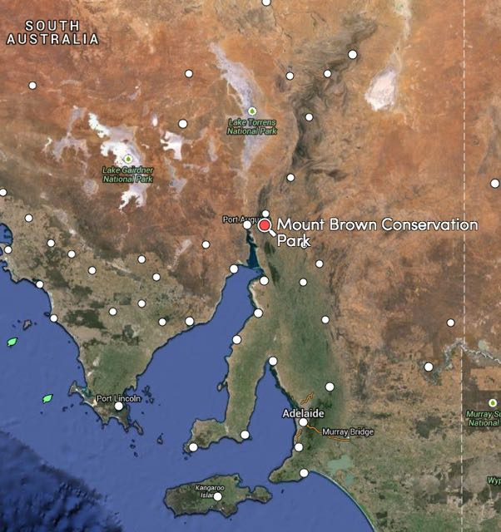
Map courtesy of mapcarta.com
On arrival we set up our stations in the car park and went on air.
Peter used his FT817nd feeding a linked dipole mounted on a 6 metre squid pole and used a LDG 817 ATU and one of the new German speech processors in line with the microphone.
This setup yielded him 9 contacts into VK2,VK3 & VK5.
I used my FT817nd feeding a linked dipole mounted on a 7 metre squid pole and managed 13 contacts into VK2, VK3 & VK5 with stations from VK4, VK6, & VK7 heard but not worked.
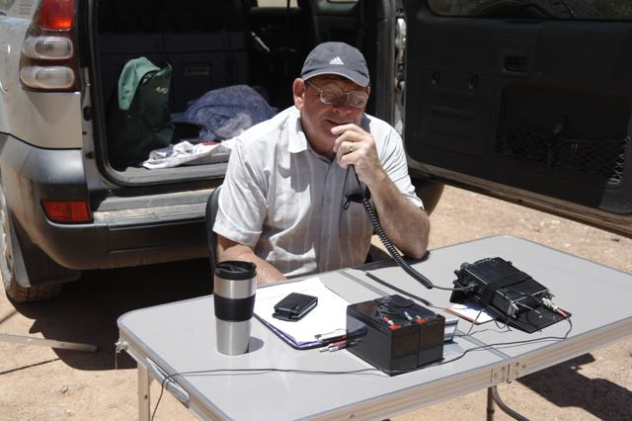
Image courtesy of Les VK5KLV
My contacts were:
VK3YSP/p & VK3FOWL/p in Lind N.P. & Coopracambra N.P., VK5TN & VK5HCF in Mount Gambier, VK3LED in Bendigo, VK3YY/p onVK-VT034,VK1NAM/p on Mt. Kurrajong,VK3ANL/p on Mt. Buller, VK3PF/p on Mt.Glenrowan, VK5BJE/p in Livingston N.P. & VK5IS.
We had an enjoyable day, spent a bit of time looking around the area, talking to each other and making the most of the good weather.
We had blue skies with wispy clouds, a light breeze and a temperature peaking at 28 degrees.
We packed our gear, reloaded the cars and after a coffee stop in Quorn we each arrived home in Port Augusta to unload & plan the next outing.

73, Les, VK5KLV.

VK5RG in the UK
By Paul VK5PAS
A few weeks ago I received an email from Rob VK5RG…..

Paul,

I can't make any Summits these days, but this one was worth attaining!

Dave Banner's mate Jim, showed me how it was done!

Good luck with the walking,

Rob VK5RG
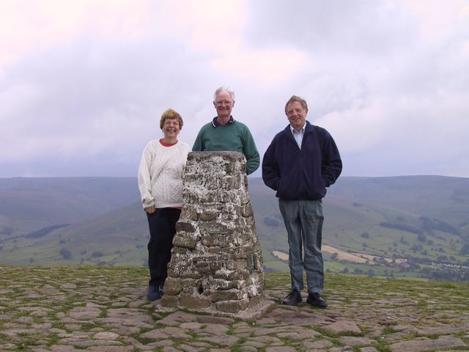

The 2014/15 UTC rollover
By Paul VK5PAS
SOTA activators can activate a summit for points, once per calendar year. That means that following the UTC rollover on 31st December, into 1st January, there are new activator points up for grabs.
So based on this, a number of activators ventured out on Sunday morning, to activate summits throughout Australia.
Here in VK5, SOTA activators included Bob VK5FO who headed to Mount Gawler VK5/ SE-013, Ian VK5CZ on Mount Ngadjuri VK5/ NE-053, and Paul VK5PAS, on Mount Bryan, VK5 SE-001.
Bob VK5FO activated Mount Gawler, in the northern Adelaide Hills, near Kersbrook. Bob made 57 contacts on 40m ssb, 20m ssb, & 6m ssb into VK2, VK3, VK5, & VK6.
Ian VK5CZ activated Mount Ngadjuri, and ended up with a total of 30 contacts on 40m cw, 40m ssb, 20m ssb, and 6m ssb & cw, into VK1, VK2, VK3, VK5, & VK6. This included 18 summit to summit (S2S) contacts.
Paul VK5PAS activated Mt Bryan, VK5/ SE-001, near Hallett in the Mid North, and had a total of 141 contacts into VK1, VK2, VK3, VK4, VK5, VK6, & VK7 on 40m ssb & 20m ssb. This included 47 S2S contacts.
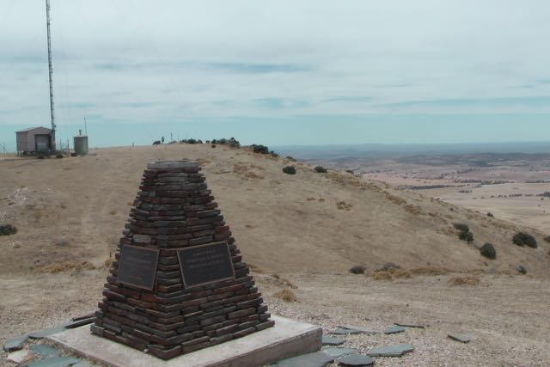
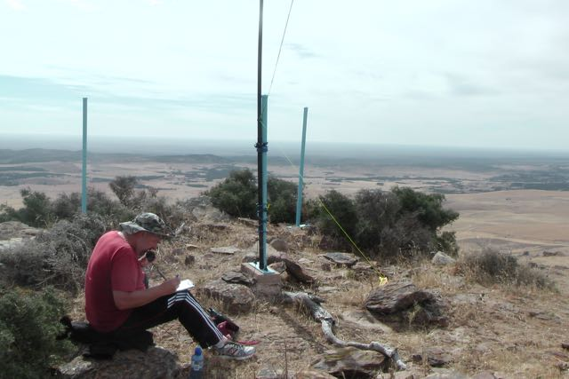
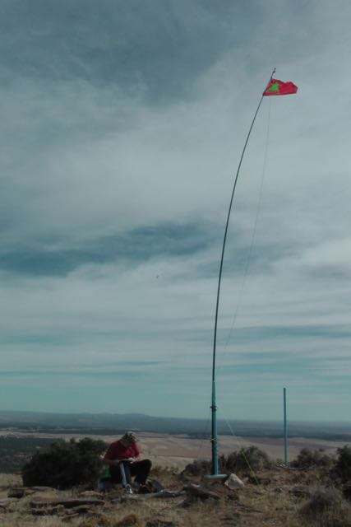

The 2014/15 UTC rollover
By Ian VK5CZ
Happy New Year everyone I hope this coming year brings many Summit activations and chasing.

Well my December activity was quiet apart from making up a new link dipole for the 6m / 10m challenge coming up in 2015 and going into our summer of 2016.

I had a couple of dx qso’s on the 6m dipole to vk4 and vk6 the day I finished making it so if conditions are right it’s possible to make 6m contacts around Australia.

My only wish is the challenge should run all year round to give activators a chance to make some 6m contacts every time they activate and score points rather than the specific months of the year set aside. We may do more activating outside those periods and make contacts on 6m but not be able to keep them as a score. I was trying to refresh my memory of the rules but I could not find them on the web page so please let me know if I have misunderstood the rules.

Getting on to some activating news rather than politics. On New Year morning I went to Mt Nadguri vk5/ne-058 for a short walk to the summit. It’s pretty dry and eaten out in them hills up there but some of the stubble down below had a nice colour to it so I included a picture of what I was looking at with a few other summits off in the distance.

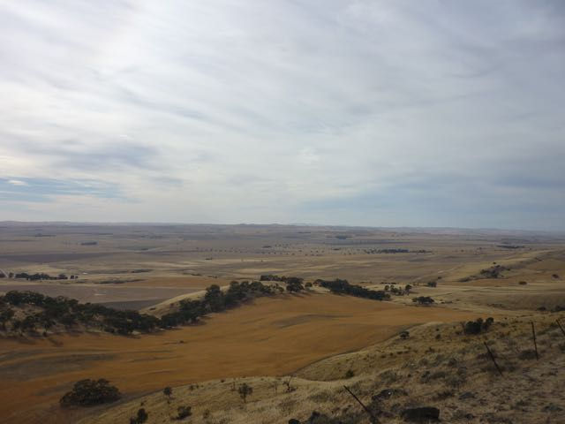
Image courtesy of Ian VK5CZ
The other shot is the new SOTA Beams link dipole I got a while ago it works very well and the signals were very good on this activation.

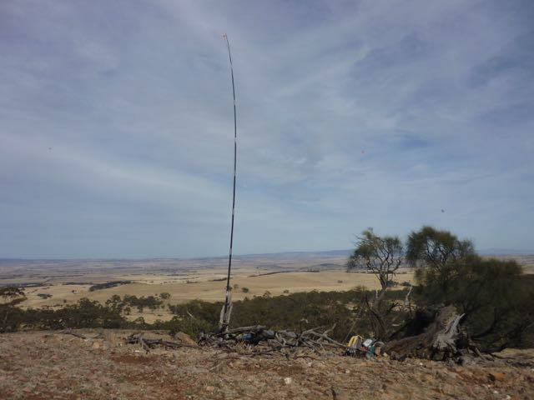
Image courtesy of Ian VK5CZ

Before UTC 00.00 roll over I had a check on 40m to find a few out activating and worked Paul VK5PAS on ssb s2s and 4 cw ops s2s with VK3BYD joining in chasing from his qrp back yard set up.

After Roll over it was rather busy once I got my spot working for me the pre emptive txt on my phone spotted me on 7.050 and I was calling on the intended 7.075 wondering why no one was chasing me. Woke up when I checked my spot.

I made 18 s2s qso’s and worked 28 chasers with Amanda in a conservation park and 3 locals on 6 m to test my antenna. The highlight for me was to work Ian VK5IS and Roger VK5NWE on 6m cw for the first time even though we worked on 3 modes on 6m with Nev VK5WG joining in on FM and SSB as well .

I went on 20m later in the activation and had some really strong signals from vk1 2 5 6 with 5 s2s on 20m as 40m did the usual thing and all the vk2s and vk3s faded into the static by 00.40 UTC.

I am not sure how many were out activating as I never got round to work everyone but it was a great way to bring in the new year.

73 all see you next time.
Ian vk5cz.

Recent Award recipients (from VK5)

WWFF

NIL
SOTA

NIL

VK5 Parks

Greg VK5GJ
- Bronze Hunter
- Silver Hunter
- Gold Hunter
- Platinum Hunter
- Bronze NP Uniques
- Silver NP Uniques
- Gold NP Uniques
- Bronze CP Uniques
- Silver CP Uniques

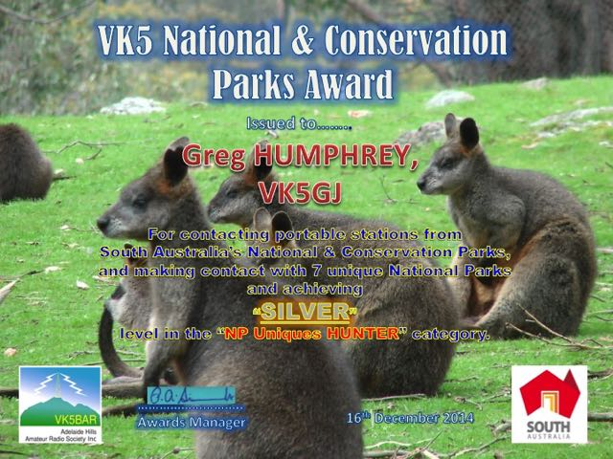
John VK5DJ
- Bronze Hunter

PLEASE, if you have qualified for an award for SOTA, the VK5Parks Award & WWFF let me know, so I can add it to the list. VK5 Parks & WWFF is not so important, due to the fact I am the Awards Manager. But please send me any info on your global WWFF awards, and also info on your SOTA Awards. These are harder for me to track down. As such, a quick email would be appreciated.

Doc’s portable set up

Thought everyone might like to see the pedestrian mobile set up of Doc VK5BUG. The photos are from last years ILLW event, when Doc set up at the Marino lighthouse, within the Marino Conservation Park.

